**CLOUD COMPUTING**

Cloud computing is a term referred to storing and accessing data over the internet.

It doesn’t store any data on the hard disk of your personal computer.

In cloud computing, you can access data from a remote server.

Physical to virtual data center access in cloud computing.

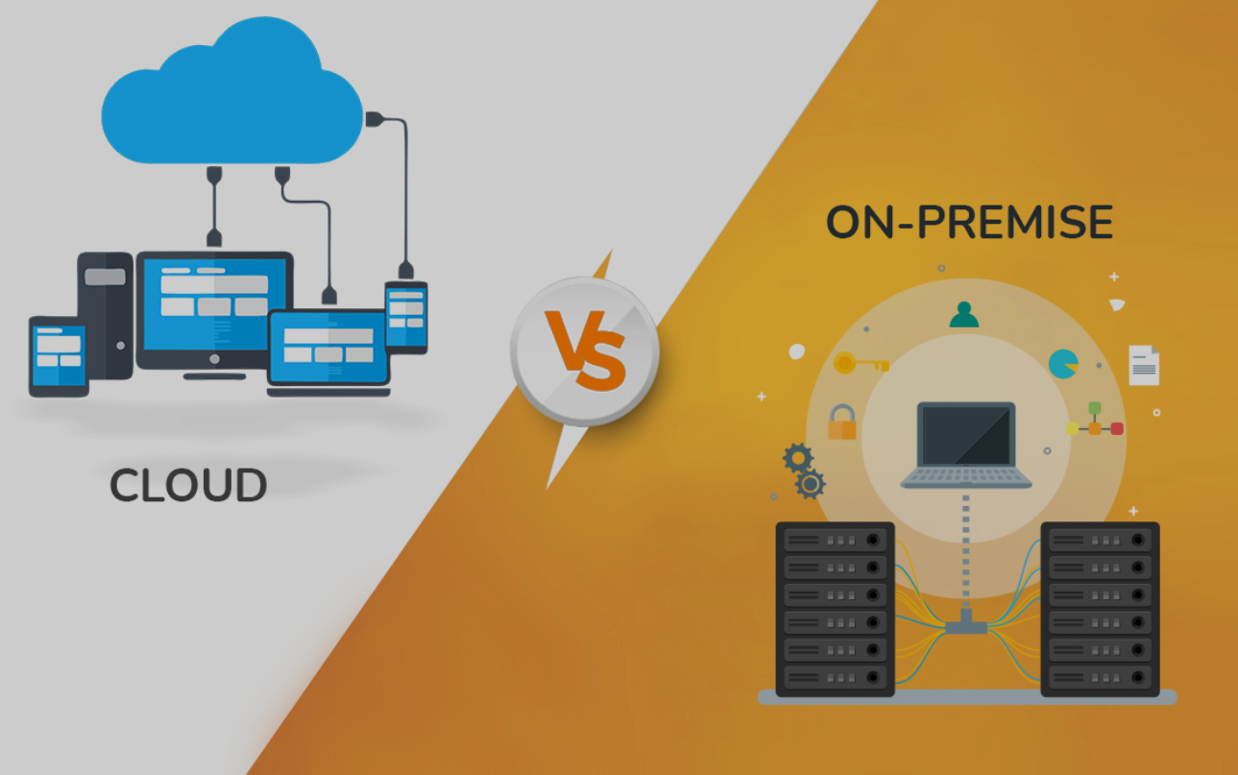

**Platforms providing cloud services :**

**AWS(40%)** , Microsoft Azure(26%) , GCP(13%) , IBM Cloud , Oracle cloud.